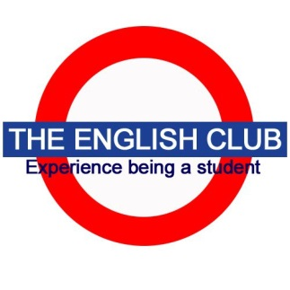
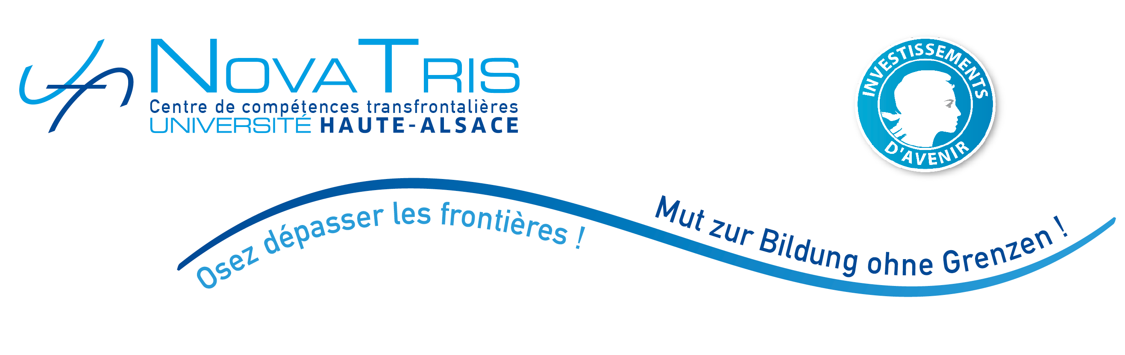

10 rue des Frères Lumière, F-68093 Mulhouse cedex

“Thursday Lunch”

Bring a sandwich along and practice your English!
Every Thursday at 12h, room 001

EUCOR Guest Lectures
Semester Program Spring 2017

January
12th Wolfgang Hochbruck (Freiburg)
19th Balz Engler (Basel)
26th Ridvan Askin (Basel)

February
2nd Dustin Breitenwischer (Freiburg)
9th Edward Still (Oxford)
16th Mordjana Haddad (Université de L’arbi Ben Mhidi de Oum El Bouaghi, Algeria)

March
2nd Jeremy Hawkins (Strasbourg)
9th Philipp Schweighauser (Basel)
16th Michael Heller & Jane Augustine (New York City)
23rd Monika Fludernik (Freiburg)
30th Fritz Gysin (Berne)

April
6th Lara Delage-Toriel (UdS)

Visitors welcome!

